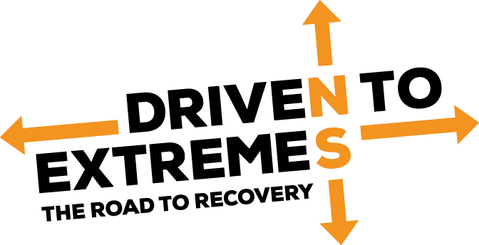
SAHARA 2024
19th September - 6th October 2024

BOOKING FORM

PLEASE COMPLETE IN BLOCK CAPITALS

Please Note: You are signing up for an adventurous driving expedition across the Sahara Desert. Some days may be long due to arduous terrain, vehicles getting stuck and mechanical breakdowns. If you are expecting a relaxing tour of Morocco with silky smooth roads and 5-star accommodation, please read no further and take a look at the latest offerings from Abercrombie & Kent. If on the other hand you want a real adventure, you’ve come to the right place!

Drivers / Co-Drivers:

Driver 1 (Primary Contact)

Name (Mr/Mrs/Miss/Ms) ___________________________________________________________________________

Known As __________________________ HM Forces Service RN ______ Army ______ RAF ______

Address __________________________________________________________________________________

Mobile No __________________________ Email ______________________________________________

Driver 2 (Minimum of 2 Drivers per Car)

Name (Mr/Mrs/Miss/Ms) ___________________________________________________________________________

Known As __________________________ HM Forces Service RN ______ Army ______ RAF ______

Address __________________________________________________________________________________

Mobile No __________________________ Email ______________________________________________

Driver 3

Name (Mr/Mrs/Miss/Ms) ___________________________________________________________________________

Known As __________________________ HM Forces Service RN ______ Army ______ RAF ______

Address __________________________________________________________________________________

Mobile No __________________________ Email ______________________________________________

Driver 4

Name (Mr/Mrs/Miss/Ms) ___________________________________________________________________________

Known As __________________________ HM Forces Service RN ______ Army ______ RAF ______

Address __________________________________________________________________________________

Mobile No __________________________ Email ______________________________________________

Vehicle:

Land Rover Freelander 1: Year: ___________________

Engine (please tick): Diesel 2.0 Td4 _____________ 2.0 L Series ______________

Petrol 1.8 K Series __________ 2.5 V6 __________________

Gearbox (please tick): Manual ___________________ Automatic _______________

Other 4x4: Year: ___________________

Make ___________________ Model __________________

Engine (please tick): Diesel ___________________ Capacity _________________

Petrol ___________________ Capacity _________________

Gearbox (please tick): Manual ___________________ Automatic _______________

Driven to Extremes SAHARA aims to become a ‘one make’ expedition so that it is easier for the Max Adventure team to provide spares support with all vehicles being the same. The vehicle we've chosen is the Land Rover Freelander 1, preferably with the Td4 diesel engine. However, for the 2024 expedition we are inviting other 4x4 vehicles to take part, but it will be the requirement of each of those teams to carry appropriate spares for their own vehicle. We will advise as to what the most appropriate spares are, along with a comprehensive kit list.

Branded Expedition Clothing:

One Driven to Extremes desert shirt is included free of charge per participant as part of the entry fee and will be handed out at the start of the expedition. Please indicate the numbers of each size required.

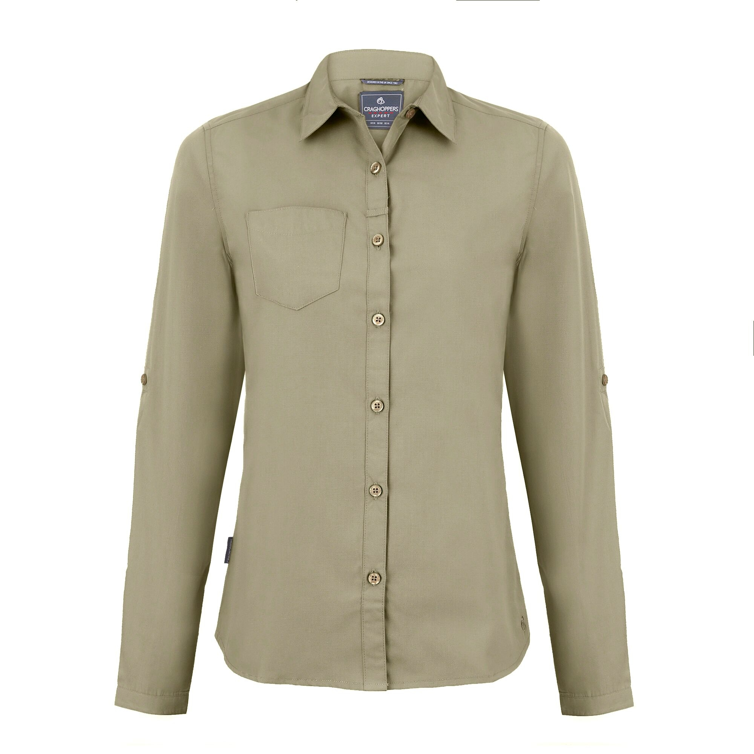
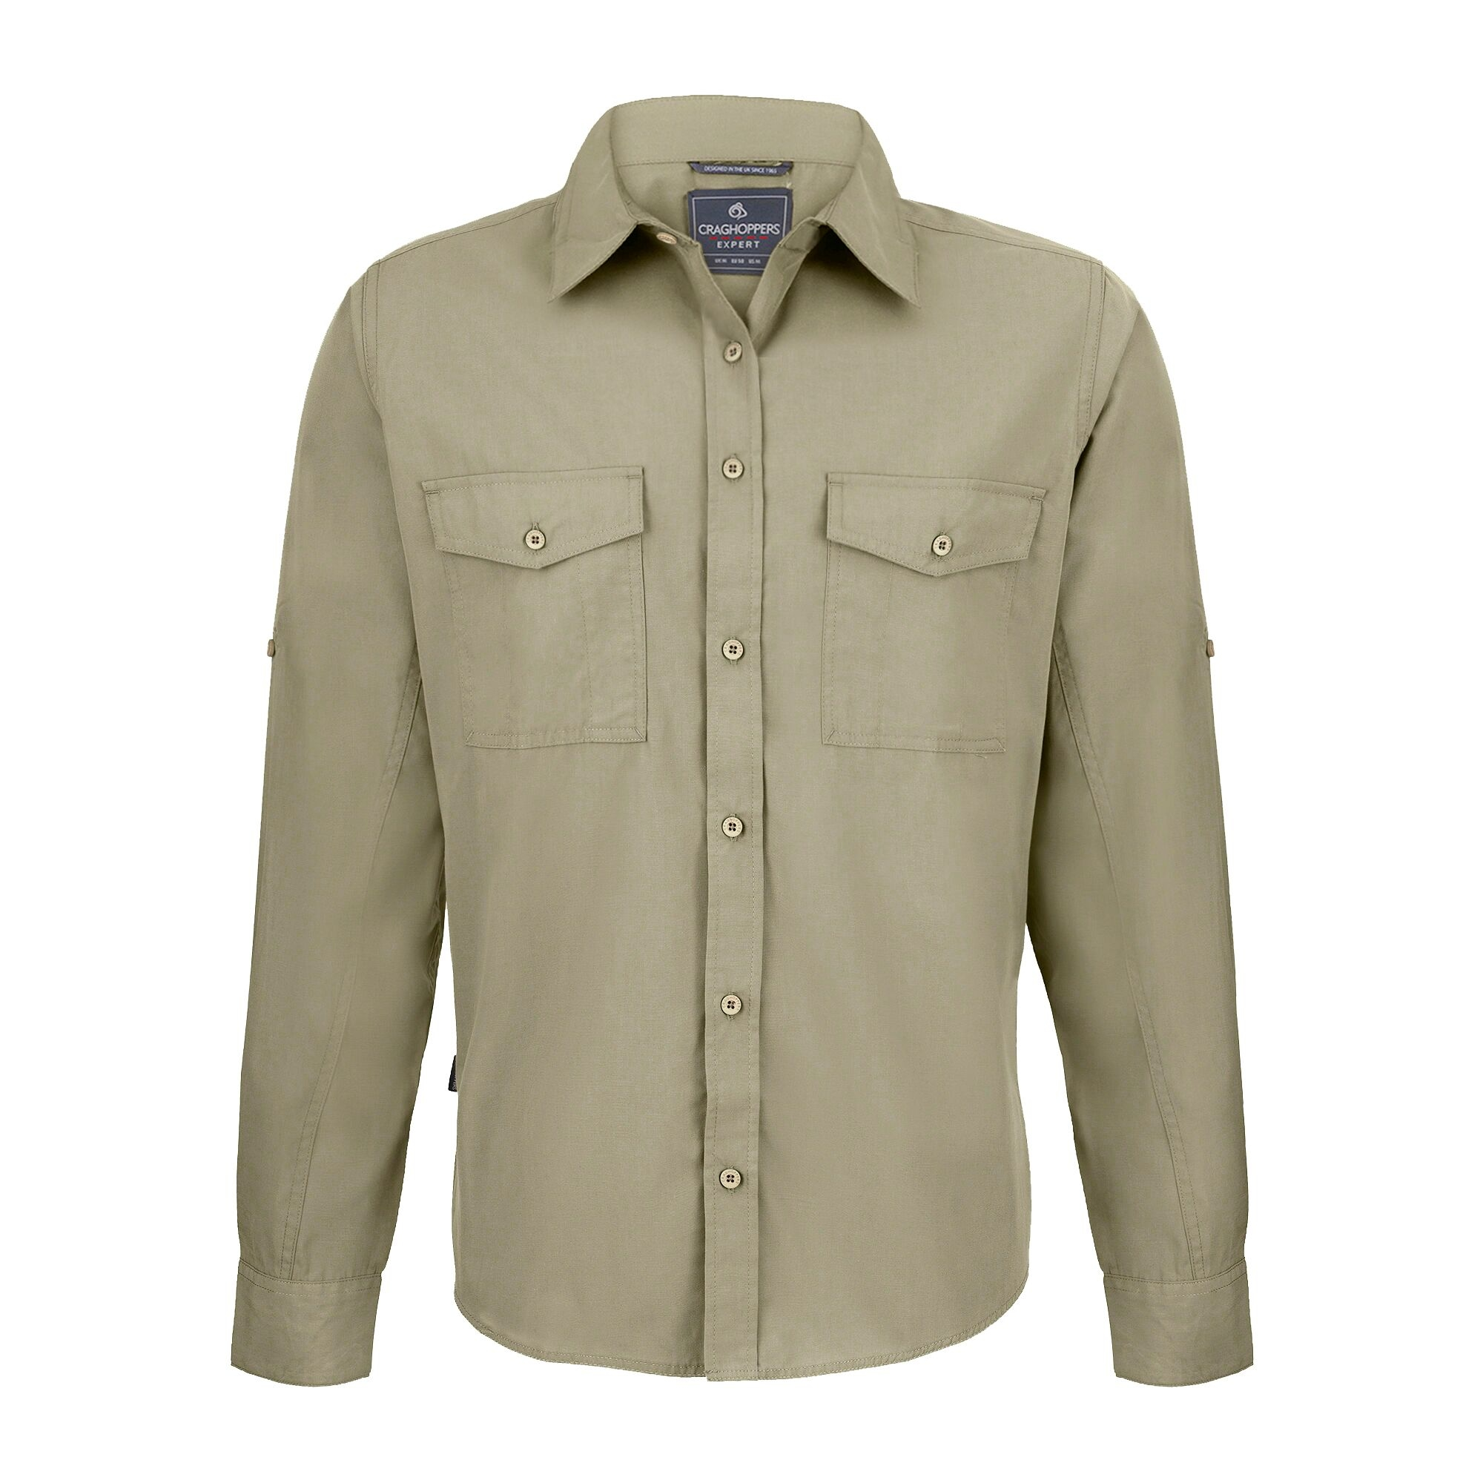

COMPLIMENTARY CLOTHING
MEN | S | M | L | XL | XXL | XXXL
Desert Shirt
WOMEN | 8 | 10 | 12 | 14 | 16 | 18
Desert Shirt

It is requested that all entrants wear the official shirt for any team photos and as frequently as possible during the event.

Additional Branded Expedition Clothing Available:

Selected for their suitability on Driven to Extremes SAHARA, we have a range of branded clothing available:

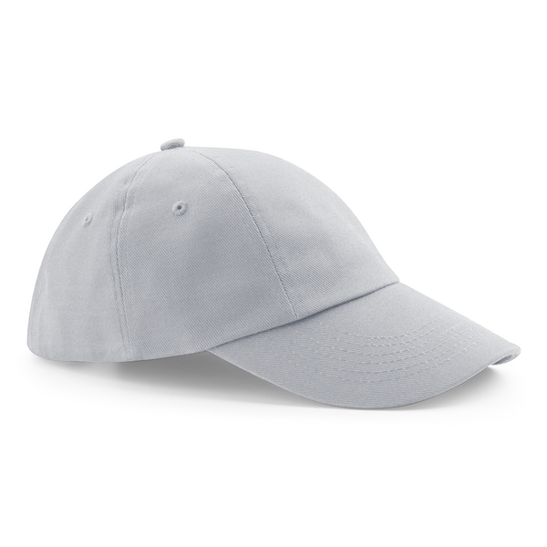

Baseball Caps

£11.95

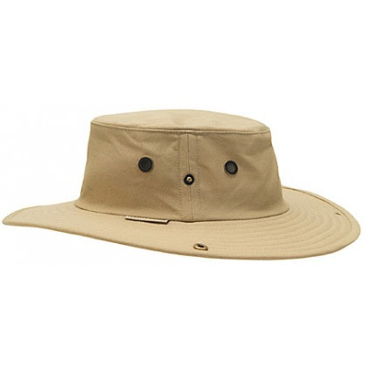

Desert Hats
£34.95

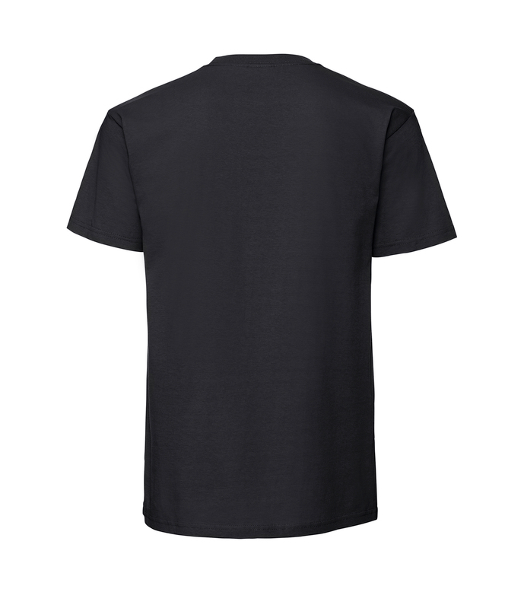
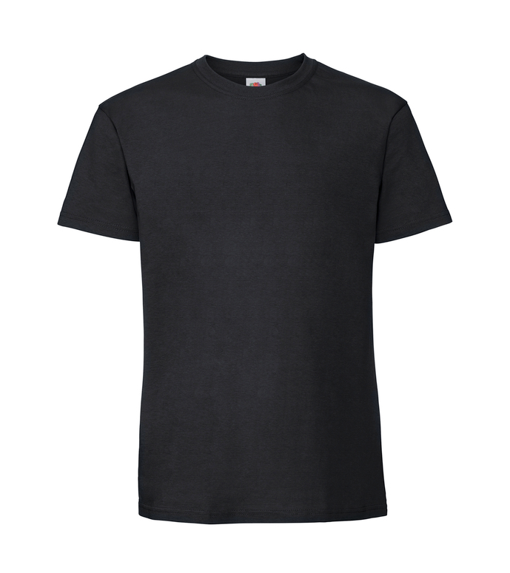

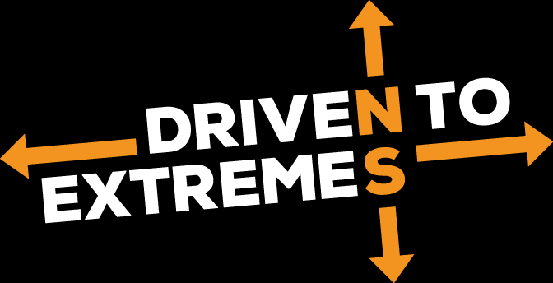
T-Shirts
£19.95

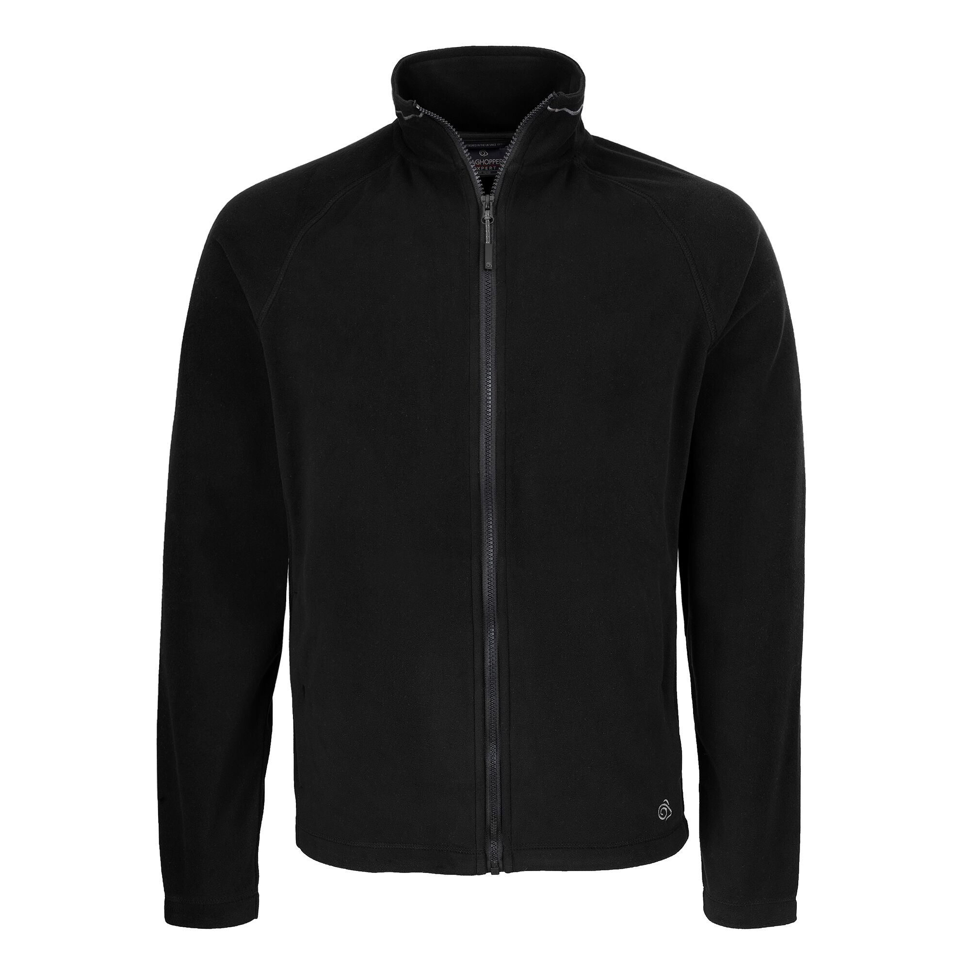
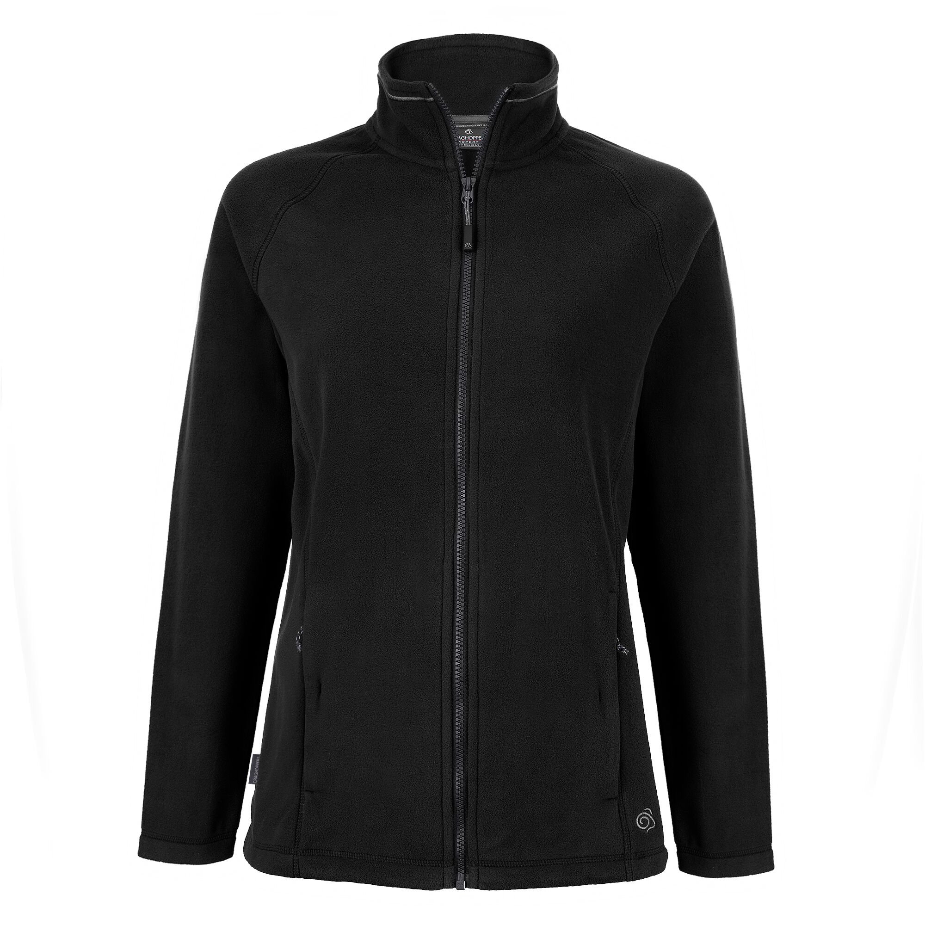

Desert Shirts
£39.95

Fleeces
£49.95

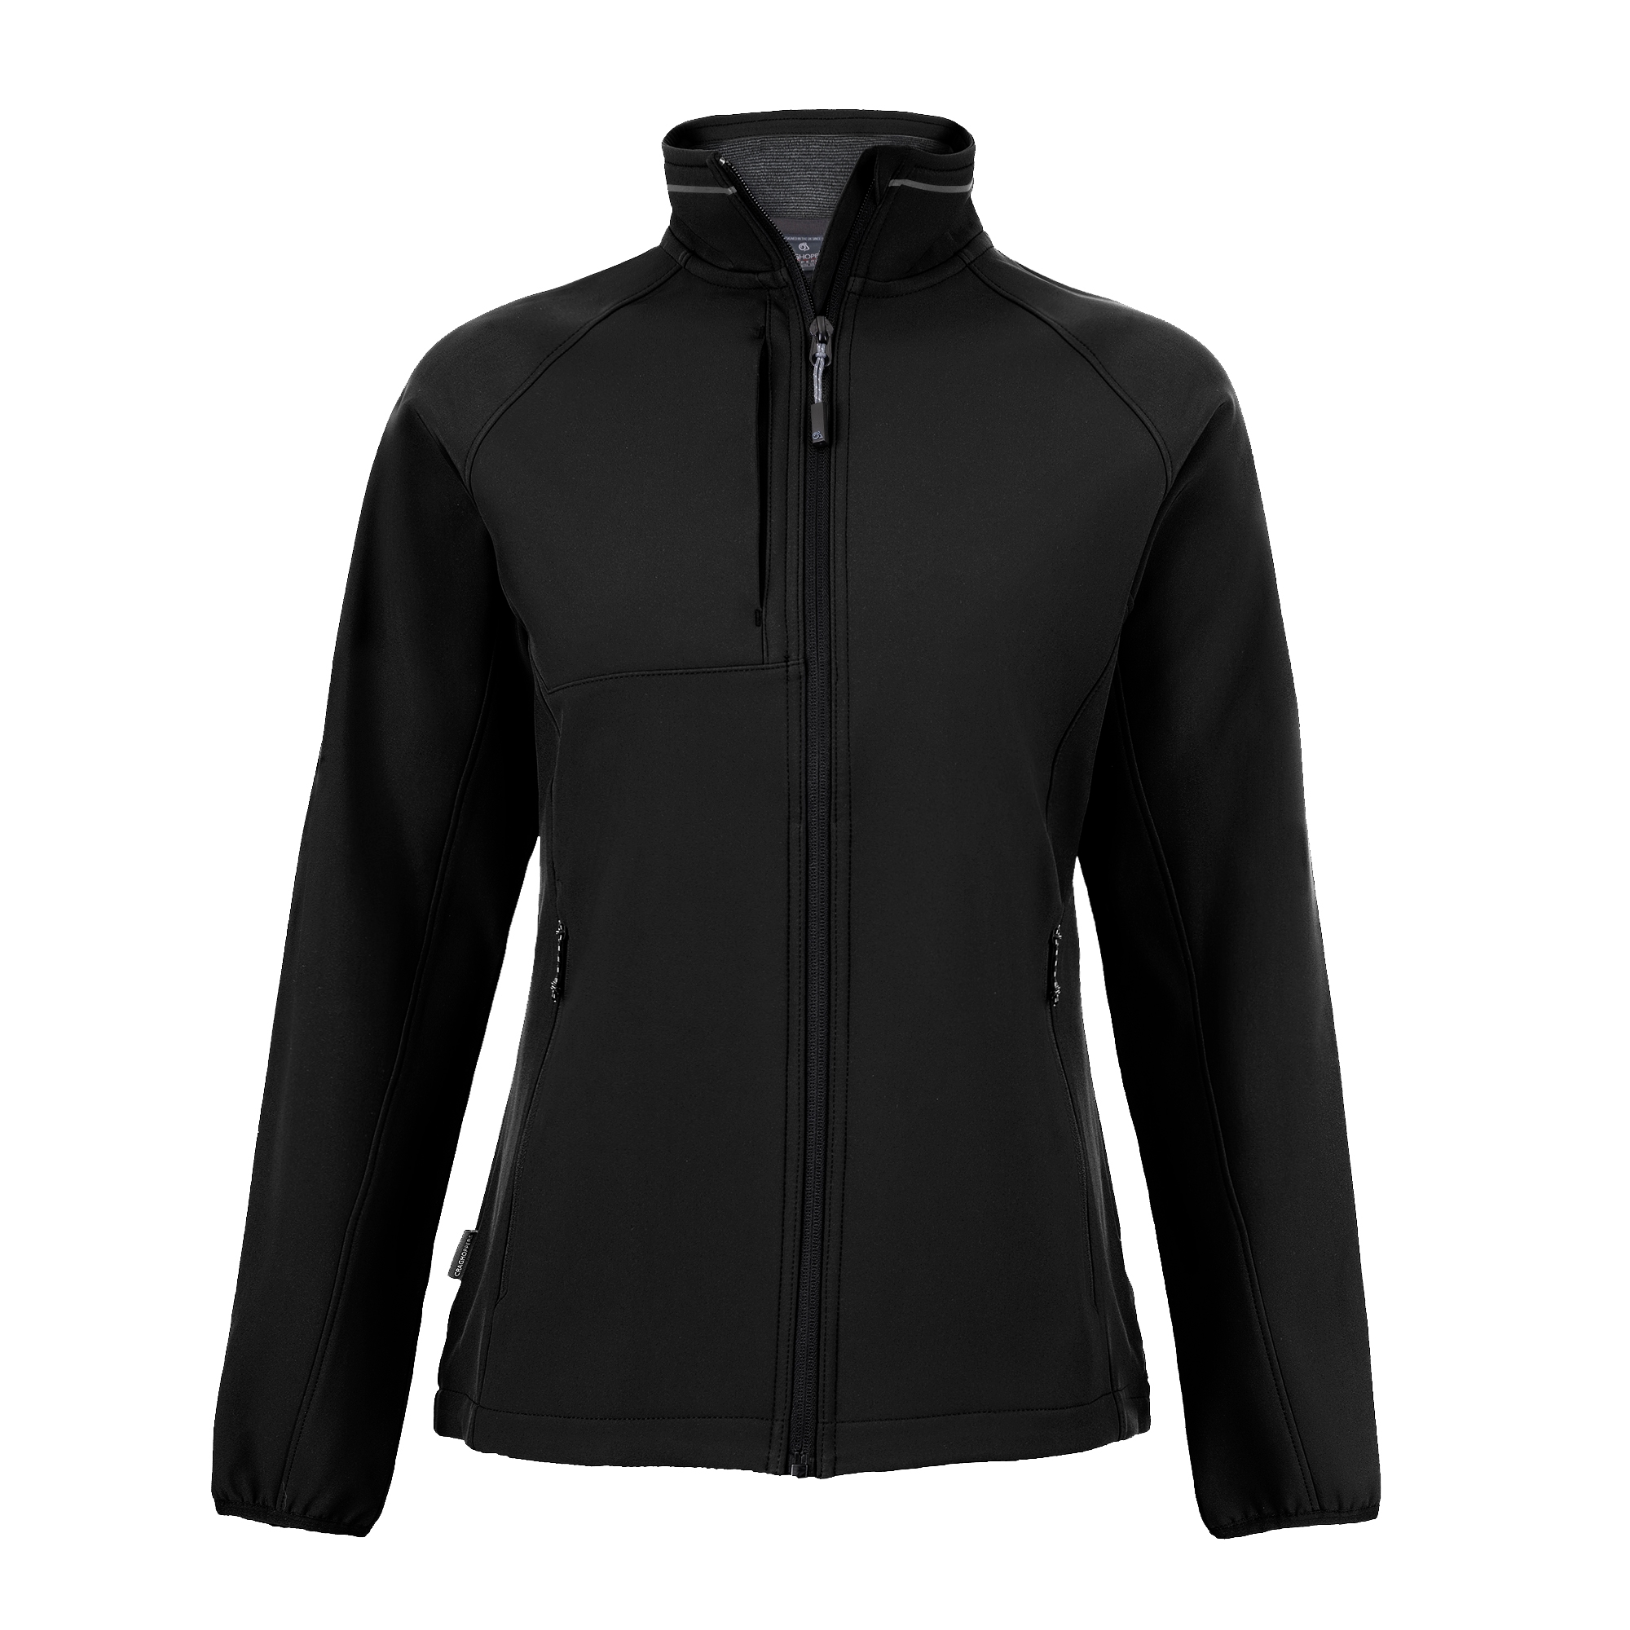
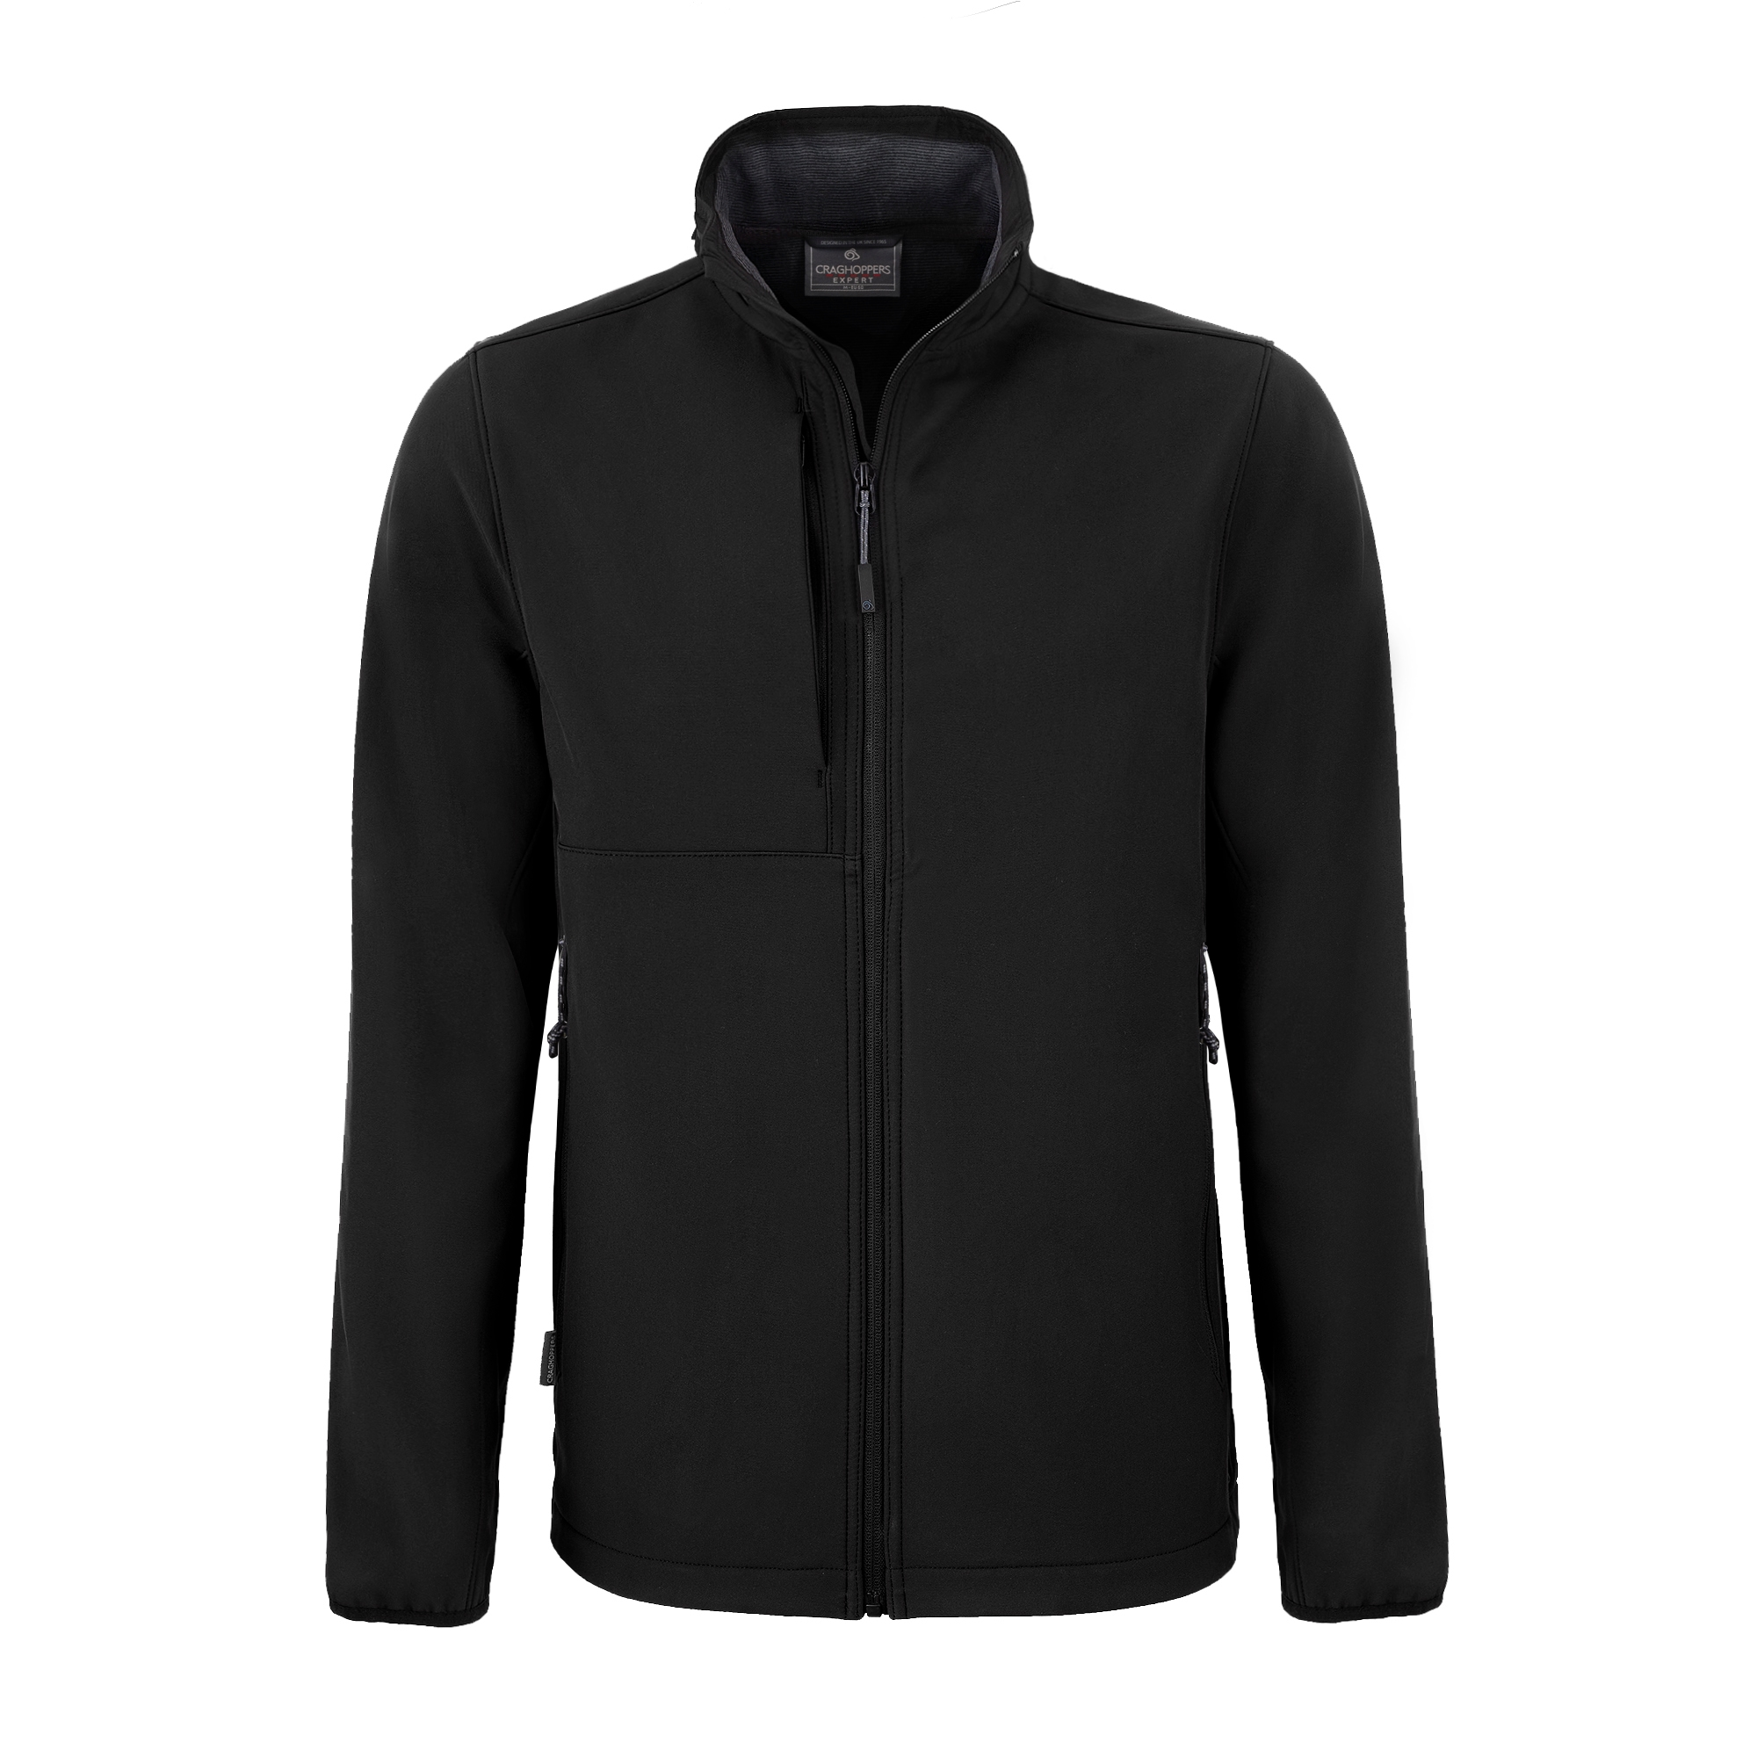

Softshell Jackets
£59.95

All prices exclude postage & packing, or items can be handed out at the start of the expedition.

BRANDED CLOTHING
UNISEX | XS | S | M | L | XL | 2XL | 3XL | 4XL | One Size
Baseball Cap
Desert Hat
T-Shirt
MEN | XS | S | M | L | XL | XXL | XXXL
Desert Shirt
Fleece
Softshell Jacket
WOMEN | 8 | 10 | 12 | 14 | 16 | 18 | 20
Desert Shirt
Fleece
Softshell Jacket

Please indicate the numbers of each size required.

Vehicle Graphics:

Participating vehicles will be required to display Driven to Extremes SAHARA logos on the bodywork of their vehicles during the expedition. These logos will be self-adhesive and appropriate for use on vehicle bodywork.

Participants agree to themselves, their vehicles and passengers being filmed and photographed during the event and that this media may be used to promote Driven to Extremes.

If seeking sponsorship as part of your entry, you can offer companies space for their logo on all vehicle bodywork panels, except for areas that are reserved for Driven to Extremes logos as follows…
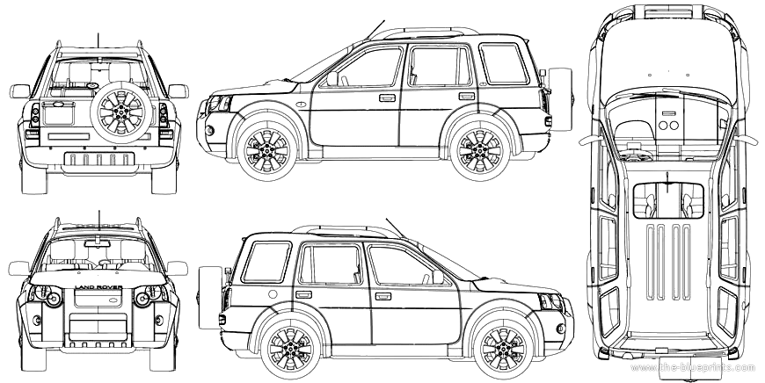

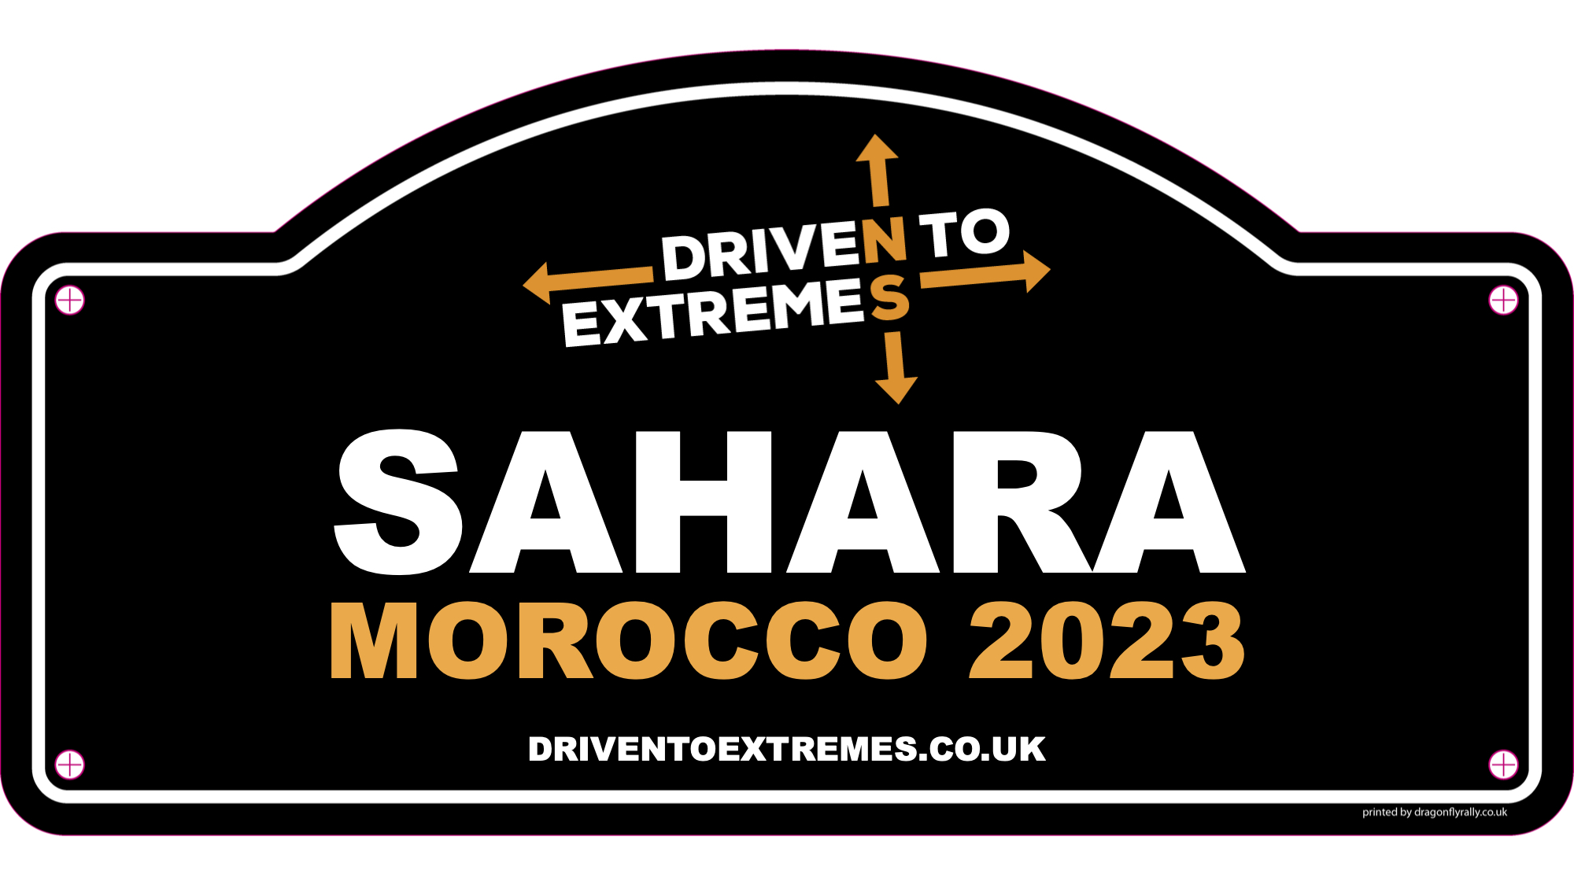

If any corporate sponsors come forward to support the whole event, you will be advised as soon as possible with regards to their logo requirements on the vehicles.

Entry Fee:

The entry fee per person includes…

- Professional support crew – Leader, Doctor, Mechanic
- Expedition prepared 4x4 support vehicles (we aim for one 4x4 per 6 vehicles taking part)
- Expedition medical, mechanical, recovery & communication equipment (incl. satellite phones)
- Return car ferries from Spain to Morocco
- 2 nights twin / double room hotel accommodation (1 in Spain, 1 in Morocco) – 2 people sharing*
- 7 nights campsite accommodation in Morocco – 2 people sharing a tent**
- 2 nights wild camping in Morocco
- UHF radio hire – full vehicle kit
- Satellite mapping for smartphones
- Satellite tracking of the expedition (available to share with friends and family)
- Branded team desert shirts
- Vehicle graphics

* Single room supplement available on request

** Individual tent supplement available on request

The expedition starts and finishes in Portsmouth, UK and all teams are asked to make their own way there. On arriving in northern Spain by ferry, we’ll have a long drive to Seville which will take approximately 10 hours. For those that would prefer a more leisurely drive to southern Spain, along with teams that live in continental Europe, we ask that you meet us in Gibraltar on the morning of Sunday 22nd September.

On returning to Spain from Morocco, European teams are required to make their own way home, whilst those from the UK can remain with the team unless they wish to drive home at a slower pace.

Early Bird Discount – Until 31st March 2024

No. in Car Entry Fee Deposit Balance

Drivers / Passengers Per Person Paid when Booking

2 £ 1,395.00 £ 350.00 £ 1,045.00

3 £ 1,145.00 £ 275.00 £ 870.00

4 £ 895.00 £ 225.00 £ 670.00

HM Forces (Regular or Reserve / Serving or Veteran) – Until 31st August 2024

No. in Car Entry Fee Deposit Balance

Drivers / Passengers Per Person Paid when Booking Paid by 31st Jul 2024

2 £ 1,395.00 £ 350.00 £ 1,045.00

3 £ 1,145.00 £ 275.00 £ 870.00

4 £ 895.00 £ 225.00 £ 670.00

Standard Entry Fee – 1st April to 31st August 2024

No. in Car Entry Fee Deposit Balance

Drivers / Passengers Per Person Paid when Booking Paid by 31st Jul 2024

2 £ 1,495.00 £ 350.00 £ 1,145.00

3 £ 1,245.00 £ 300.00 £ 945.00

4 £ 995.00 £ 250.00 £ 745.00

If your application is accepted it is understood that the deposit is non-returnable in all cases, other than organiser’s negligence, cancellation of the event due to Force Majeure (circumstances beyond our control), or the event not reaching the minimum number of entrants required for it to take place (6 cars).

Confirmation of your successful application, along with further information, will be emailed to you. If your application is not successful, your deposit will be returned.

The remaining balance must be received by the dates listed above, after which date any entry not paid in full will be deemed null and void. No refund will be given.

We are also offering a further £100 discount per team for introducing additional entrants that sign up to the expedition.

Payment:

Payment can be made by cheque payable to:

Max Adventure Ltd and sent along with this application form, or by BACS:

By BACS: Bank: Lloyds Branch: Bracknell
Sort Code: 30-91-11 Account No: 03558000

SWIFT / BIC: LOYD GB 21059 IBAN: GB52 LOYD 3091 1103 5580 00

Reference: Please make any BACS payments with the reference
SAHARA24 (followed by your name)

Your participation on the expedition can only be guaranteed upon receipt of payment.

Public and Products Liability Insurance:

The organisers at Max Adventure Ltd have a £2.5 million Public and Products Liability Insurance in place supported by Tasker & Partners Ltd. This policy is wholly unconnected with the vehicle insurance requirements for each entrant; vehicle insurance cover remains the responsibility of the entrant.

Indemnity:

I have read the application form and any regulations issued for the expedition and agree to be bound by them and by any additional instructions issued by the organisers.

I am aware that this expedition is of considerable duration including a number of very long days. I confirm that I am aware of the endurance element and have taken that into account when applying. I am aware that any routes are driven at my discretion.

In consideration of the acceptance of this entry or of my being permitted to take part in the expedition, I agree to save harmless and keep indemnified any sponsor or partner of the event, Max Adventure Ltd, the organisers, such person, persons or body as may be authorised to promote or organise this expedition and their respective officials, servants, representatives and agents from and against all actions, claims, costs, expenses and demands in respect of death or injury to myself / my crew howsoever caused arising out of or in connection with this entry or my taking part in this expedition, and notwithstanding that the same may have been contributed to or occasioned by the negligence of the said bodies, their officials, servants, representatives or agents.

Furthermore, in respect of any parts of this expedition on the ground where third party insurance is not required by law this agreement shall in addition to the parties named above extend to all and any other entrant(s) and their servants and agents and to all actions, claims, costs, expenses and demands in respect of loss or damage to the person or property of myself, my driver(s), passenger(s), mechanic(s), or associated personnel.

I declare that the vehicle hereby entered is roadworthy and the use of the vehicle will be covered by insurance as required by the law, which is valid for such part of this expedition as shall take place on roads as defined by the law.

Communications & Safety:

In order for the whole team to remain in close contact with each other, each person will be required to purchase a Moroccan SIM card on arrival in country (approx. €20.00). Even though you will now have a Moroccan telephone number for the duration of the expedition, your WhatsApp account will still work as normal so allowing communication with friends and family back home.

We ask that you agree to share your WhatsApp contact details with other members of the expedition via a dedicated Sahara2024 WhatsApp group. This allows the support crew to quickly and easily share information with the whole team.

Please Note:

As this is a vehicle expedition through challenging terrain and therefore subject to the weather, mechanical breakdowns and route conditions, Max Adventure Ltd have the right to alter the itinerary at any time to ensure the overall safety of the team. Any alterations will be discussed in advance of changes, but a flexible approach to the itinerary is therefore required by all those taking part.

The Road to Recovery:

Driven to Extremes was founded in 2017 by expedition specialists Max Adventure in support of injured military veterans by taking them on challenging vehicle adventures to aid their recovery from PTSD. Whereas some activities such as Atlantic rowing or Polar trekking can allow too much thinking time, vehicle expeditions can cross continents in a matter of days. The intense exposure to new and exciting experiences within a challenging team-based environment helps push horrific memories to the back of their minds. We ask that each team therefore raises a minimum of £250 in support of veterans that will join us on a Driven to Extremes Expedition.

Entry Form – Sahara 2024:

If you wish to take part in Driven to Extremes Sahara 2024, please sign below to confirm that you accept the terms and conditions outlined above.

Driver 1 Date __________ Name __________________________ Signed ________________________________

Driver 2 Date __________ Name __________________________ Signed ________________________________

Driver 3 Date __________ Name __________________________ Signed ________________________________

Driver 4 Date __________ Name __________________________ Signed ________________________________

Pages 1, 2, 4 & 7 of this form should be completed and sent to…

By Post Max Adventure Ltd, The Carpenters, Axminster, Devon EX13 7EB

By Email info@maxadventure.co.uk

Further Information:

For further information please contact Mac: Mobile: +44 (0) 7764 600 601
Email: info@maxadventure.co.uk

